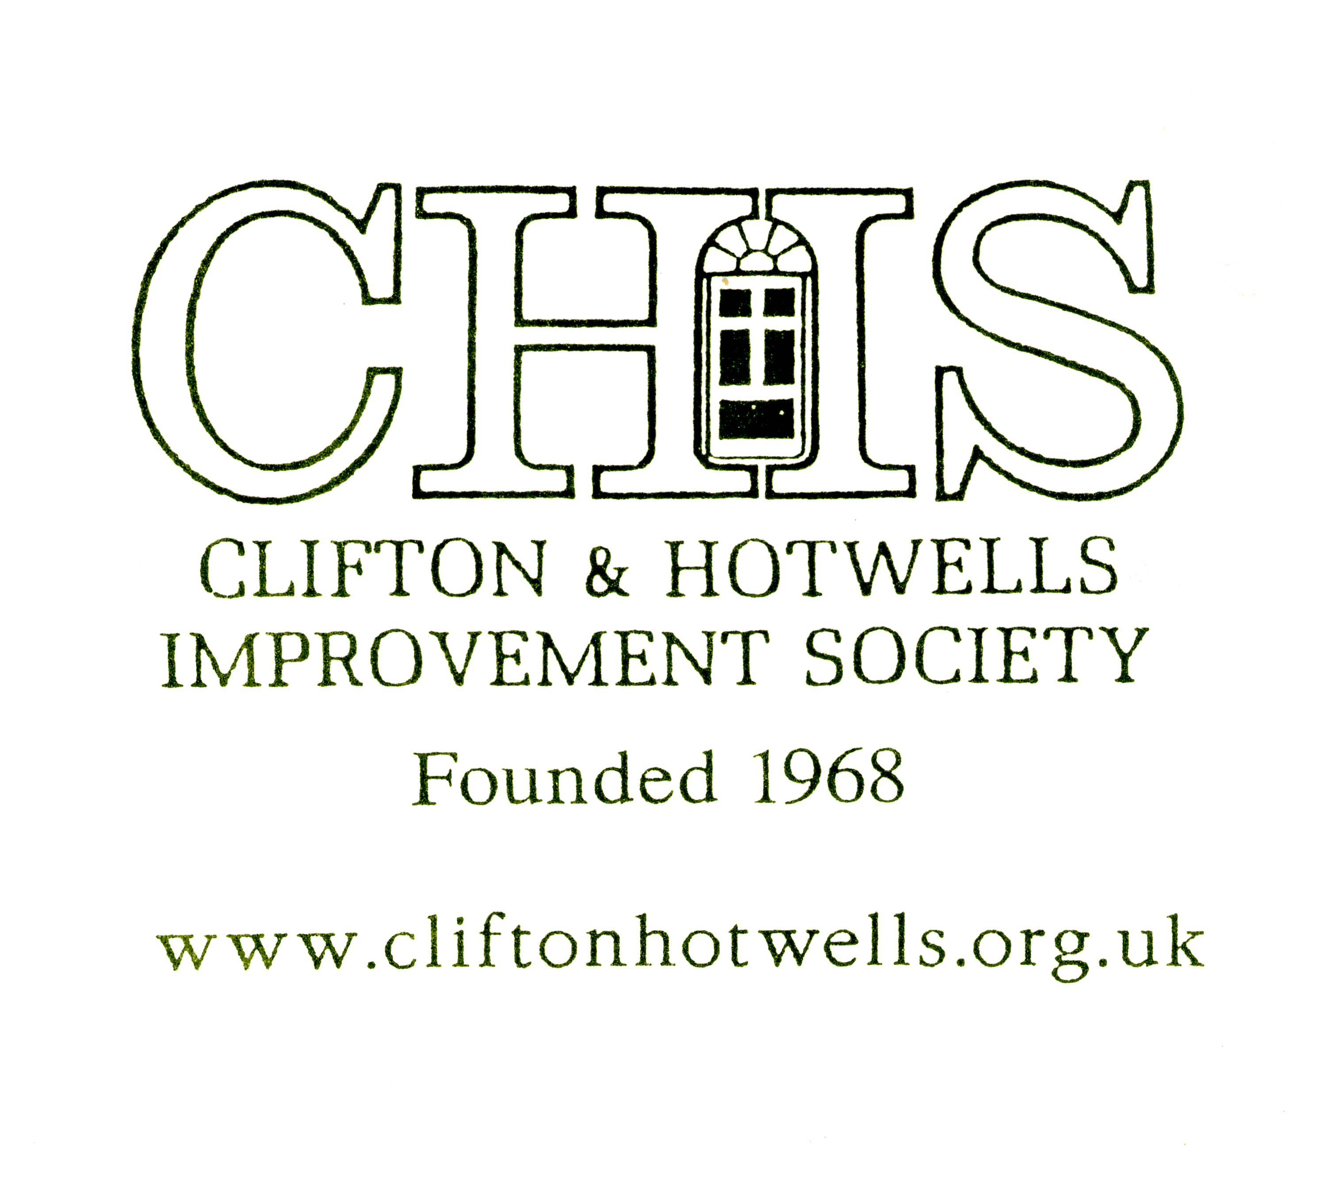 | 101 Queen’s Road Clifton 08/05172/F | PLEASE WRITE IN AND STOP THIS LATEST TOTALLY INAPPROPRIATE DEVELOPMENT
Proposal: Part 2/part 4 storey extension to existing two storey student accommodation building to provide 4 storey residential development comprising 12 no. one, two and three bedroom apartments and new retail premises within Use Classes A2 & A3.
More details on the planning section of http://www.bristol.gov.uk. Please write to North and West Area Planning Team, City Development, Brunel House, St Georges Rd, BS1 5UY or email north.planning@bristol.gov.uk
Closing Date for objections: 21 February. You must quote the application number. When writing as individuals about this development, make sure to state your context (resident, local shopkeeper, etc) as well as your reasons. Please help to stop this latest development by writing in again (looking at http://www.cliftonhotwells.org.uk may help).
You may wish to use some of the following information.
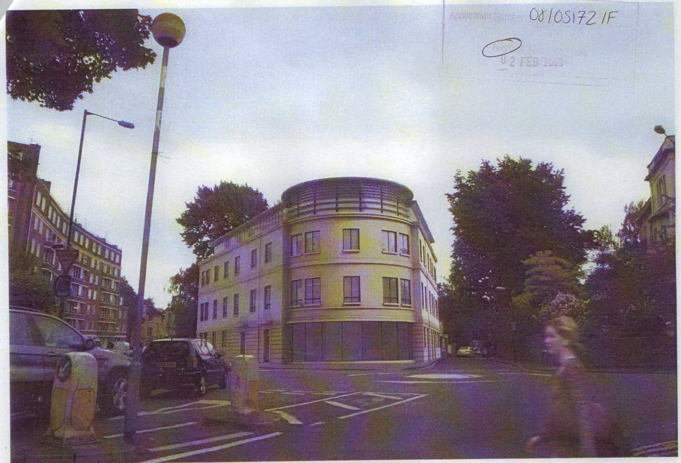  View from Students Union (totally out of context with Richmond Hill) | 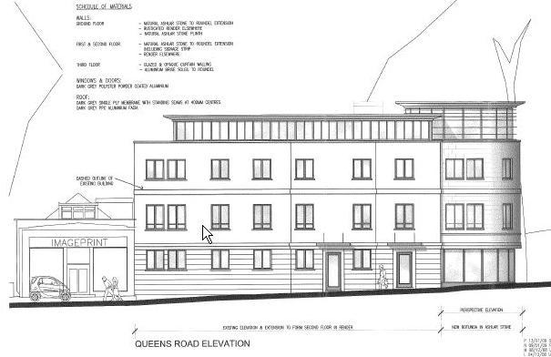  Side elevation (dwarfs ImagePrint!).
Facts:
Yet another application for a new building on this prominent site at the busy junction on Queens Road. The Council rejected the previous application for this site (08/00412/F &. 08/00413/LC)…for the following reasons:
- The proposed development by reason of its height, scale and massing, its position at the back of the pavement on Queens Road and external appearance would represent an incongruous form of development that would harm the character and appearance of this part of the Clifton Conservation Area contrary to policies B1, B2, B6, B8 and B13 of the adopted Bristol Local Plan. Failure to comply with any one of the above Policies constitutes sufficient, adequate and necessary reason for refusal.
- The proposed development fails to make adequate provision for the parking and manoeuvring of bicycles within the curtilage of the site and is therefore contrary to policy M1 of the adopted Local Plan 1997.
The existing building on the site is not a good one, but does not draw the eye like this one. This latest plan is just as high, just as massive, and just as incongruous!
- The proposed building is totally different internally and externally and can not be built without demolishing the existing one so why is there no application for demolition! It is certainly not a conversion.
- The proposed building plans show 1.5m of Richmond Hill highway being used as a service area!
- The latest proposed plans confusingly show a shop on the corner, but the February photos show the shop next to ImagePrint! Outdoor seating is not feasible since the pavement is too narrow and inappropriate. It also describes the proposed building as part 2/part 4 storey, but it appears to be part1/part 4 storey! Existing floor plans are not given.
- Height: the four storey building contravenes and conflicts with the predominantly two storey historical built form of the traditional and listed villas. The existing buildings in the block bounded by Queens Road and Richmond Hill are either 2 storey or 2 storey villas with an attic storey above cornice level. Pre-war and modern buildings (especially the student union building) do not provide any kind of exemplar to be emulated. They provide examples of development which have damaged the Conservation Area, and which do not embody the principles of PPG15 and the Local Plan. The proposal fails to comply with Bristol’s Tall Buildings Policy. Ever since 1972, every application to make this building higher has been refused, so why approve it now?
- Built Form and Massing: the characteristic historical built form of the local area, especially on the parcel of land bounded by Queens Road and Richmond Hill, is the symmetrical grand neo-classical Georgian detached and semi-detached rectilinear villas in landscape setting of trees and lawns set well back from any boundaries. This triangular building is in stark contrast, and without soft landscaped setting. The massing and scale of the building, and its architectural elements remain entirely inappropriate:
- The position of the building right on the back of pavement is again entirely inappropriate and unacceptable. Fails to follow established building lines and substantial set backs from the back of pavement. The site is unsuitable for development at all. Any development site which respects the front and rear set backs, and is set back from the corner would produce a footprint too small to permit a building of the necessary height, mass and scale
- The application does not include a conservation area analysis, contextual site plan or model, showing the relationship and full impact of the building to the other characteristic 2 storey villa form buildings on Queens Rd, Richmond Hill, Pembroke Rd and St Paul’s Rd. It only includes one highly misleading photomontage making it difficult to assess the impact of the proposal on the Local Conservation Area. The Design & Access Statement is inadequate and irrelevant.
The scheme, fails to relate in any way what ever to the architectural characteristics of this part of the Conservation Area: it is designed in an altogether alien architectural form and style. It fails to comply with the relevant policies and requirements of the Bristol Local Plan. ‘unless of truly excellent design, the proposal must blend with its sensitive surroundings’. Any new scheme must be constructed of the materials predominant in the local conservation area. In this part of Clifton, the neo-classical buildings have entirely ashlar Bath stone to their elevations facing the principal street frontages. Render forms no part of the architectural vocabulary of materials, yet render is the main facing material in this proposal. This scheme is neither of truly excellent design, nor does it relate (let alone blend) with its sensitive surroundings so fails to comply with policy B1, B2, B6, B8 and B13.
- Community Involvement: This scheme has not been subject to any meaningful kind of community involvement whatever. Plans were set to CHIS in November were for 12 cluster flats for students incorporating 35 bedrooms! The CHIS response has been omitted- did anyone meet? Write a letter?. The Council wrote a letter to the developers on 24 December 2008 telling them to carry out a pre application community involvement but this did not occur. Validation requirements expect major applications to carry out local community involvement
- Architectural Language: the architectural language of this part of the Conservation Area is Georgian Classical. Any new infill should blend, The following architectural elements fail to reflect the architectural language and characteristic s of the local conservation Area:
- Walls: of smooth or rusticated render. The small amount of ashlar stonework proposed does nothing to make the proposal acceptable. The predominant walling material in this part of the Conservation Area is ashlar Bath stone.
- Window surrounds: plain and set in render without window surrounds rather than in classically detailed stonework. .
- Windows: dark powder coated aluminium windows are entirely inappropriate in an area of where multi-pane Georgian timber sash windows are the norm. They appear to be of modern casement or pivot design, and located flush with the front face of the wall. Pane sizes are large and inappropriate.
- Proportions: proportion is a fundamental characteristic of Georgian buildings and of Georgian Clifton. To design a building in Georgian Clifton requires a fundamental intellectual understanding of Classical Architecture. This design shows no such understanding. The windows display a variety of proportions, all totally at variance with the local Georgian tradition and proportional system.
- 3rd storey materials: obscure glazing does not occur in the Conservation Area and is not part of the character. This has a large visual impact.
- Use Classes: The current use class is student housing for 21. The proposal is for 12 residential apartments with 25 bedrooms, but the design statement and plans do not correlate. Bedrooms at ground level with windows opening directly off the pavement provide an problems of visual privacy and security.
- The access to the bicycle store via two sets of doors is neither practical nor acceptable. Bicycles will clearly be left on the street. The proposal is now for residential use, but no parking space is provided.
- Noise: There appears to be no provision of sound insulation, for the residents on a noisy and polluted road.
- Privacy and infringement of the Amenity of Neighbouring Residents: The proposed new four storey building is sited only a few metres away from the front wall of number 19/20 Richmond Hill, 99 Queens Road, and the Catholic Chaplaincy and would overlook them. This is unacceptable.
This is a residential area where people live and sleep. Local residents do not wish to have further cafes, bars on their doorstep. The potential disturbance and intrusion would be intolerable.
- Sustainability: The application is defective because it fails to provide a quantified and independent sustainability audit which demonstrates that the project meets or exceeds current best practice. It is not environmentally sustainable and makes no attempt to address the sustainability agenda The proposal fails to comply with contemporary sustainability criteria, and by a very wide margin.
- Refuse and Recycling: The refuse area for the café is sited in Richmond Hill. 1.5m of Richmond Hill highway shown as a service area The residents bin store for 25 is minimal. The comments of the Councils waste recycling officers would need to be obtained with regard to the adequacy of the provision, the arrangements for collection and the access arrangements for refuse vehicles.
PLEASE WRITE IN AND STOP THIS LATEST DEVELOPMENT

