Nuffield Health Bristol Hospital
Upper Byron Place
Clifton
Bristol
BS8 1JU

INFORMATION ON THE CHESTERFIELD HOSPITAL RE-DEVELOPMENT PROJECT
Monday 26th November 2012

Dear Neighbour,

The week ahead commencing Monday 26th

At a risk of sounding repetitive, works on site will be very much a repeat of the last few weeks including the seemingly never ending battle against the elements. Have you ever known a year like it for such miserable wet conditions?
- Works will continue on the structure of the new Hospital building. Formwork is now being erected ready for the first floor slab. Ready-mix concrete lorries will be delivering to site throughout the week. The photograph below shows a concrete pour in progress. This is a section of the ground floor slab being constructed.
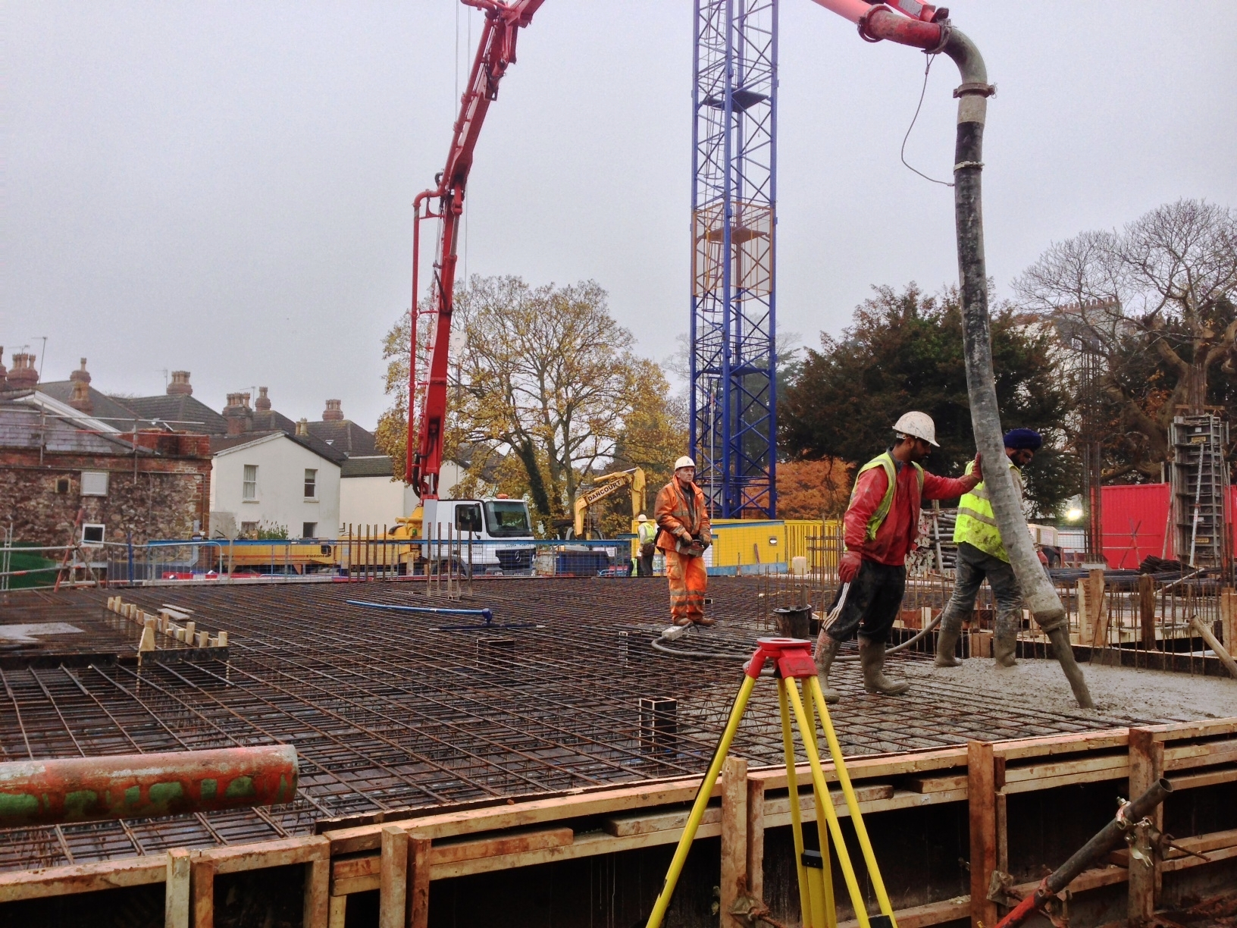
- The internal refurbishment works on the Grade II* listed building will be ongoing.
- Stone refurbishment works are in progress and will continue to the front elevation of the former Clifton Court manor house.
- The roofing contractors will continue to battle against the elements as they continue their works to replace the various slate roofs on the Grade II* listed building.
- A very small amount of spoil being generated on site will be removed using the muck-away lorries.

Best regards,

Steve

Steve Nicholson
Nuffield Health Site Manager - Chesterfield Re-development Project
Telephone: 07917 240937
Email: thechesterfieldenquiries@nuffieldhealth.com

