97 Princess Victoria Street
Clifton BS8 4DD
1 June 2011

11/01883/F, 11/01884/LA: Proposed residential dwelling, with associated access onto Princes' Lane, car parking, amenity space and refuse storage. Works to existing boundary walls.

I am writing as a close resident, and on behalf of the Clifton and Hotwells Improvement Society. We feel very strongly about this application because of its sensitive location. The last time an application was proposed in this area, the Civic Society and Clifton and Hotwells Improvement Society went to High Court. Because there was so much paperwork to wade through (much of it misleading and incorrect) this statement is longer than normal.

Constraints
Name | Constraint Type | Status
Avon Gorge | Site Of Special Scientific Interest | Adopted
Avon Gorge Woodlands | Special Area of Conservation | Adopted
Clifton Down | Common Land
Clifton | Conservation Area | Adopted
Listed Building Grade: II | Listed buildings
Name: Sion Hill Class: Unclassified Status: | Adopted Highways | Adopted
EA5 | Floodzone1

History
- Landscape and visual impact statement confirms terraces actively used for horticulture.
- Confirms that remains of small structures are likely to be hot houses or greenhouses. There has never been a dwelling on this site.
- The last development in this area was over 100 years ago.
- 412 Hotwell Road and the Colonnade were built over 250 years ago.
- The nearby Clifton Rocks Railway was only allowed to be constructed provided it was built in a tunnel, to avoid spoiling the beauty of the Gorge.

Other relevant Planning consents
09/02211/F Erection of a new dwelling and garage in Sea Walls Road.. This is cited by the developer as an example of planning permission granted on the slopes of the Avon Gorge. However, this is outside the site of Special Scientific Interest and Special Area of Conservation and is not within the view of the Suspension Bridge. It falls outside the designation of protected open space on the Avon Gorge. The area is mainly residential and the site was not part of a listed curtilage.
08/02753/LA use of land for one parking space and associated engineering works. This was for a motorcycle. The boundary wall would stay intact. The visual impact was negligible (a very small supporting wall) and should not be used as an excuse by the developer to build a huge structure over four levels as implied in the planning supporting statement.
09/015158/VC site clearance of thirteen trees and retention of one oak tree. Relevantly two pear trees, two cherry trees, seven apple trees, and a lime tree were cleared – proving that it was in fact an orchard. The oak tree seems to have vanished too. The reason given was to prepare the land for potential development pre-planning. Unfortunately permission was granted because of the condition of the trees. However. the delegated report states that the area is an important area with regard to its setting within the curtilage of two grade two listed buildings. As such, its character as planned formal gardens should be preserved within the historical setting. Interestingly enough, it makes no mention of the reason for site clearance. I submitted two letters but inexplicably neither was mentioned in the report.
09/01467/LA, 09/01466/F urgent works to stabilize and repair collapsing retaining walls. Lime mortar had to be used. Interestingly enough there was a site survey attached and a method statement which stated:
- There is a precedent of failure of such walls in terms of local stability issues.
- There is a precedent of failure of such walls in terms of global slope stability issues owing to the presence of mudstone sands within the geological sequence that create failure planes beneath the formation levels of the terraces.
- The wall had moved laterally up to 300mm- demonstrating the instability of the ground. It was likely to require further strengthening work.
- Most of the digging behind the top section of the wall had to be undertaken by hand or by hand-held mechanical tools.
- The repair by the grotto was to be dug exclusively by hand.
- If a mechanical mini-digger was required, its use had to be confined to areas 3 metres away on either side from the centre of the grotto. The depth of this level is only just over 11 metres.
This demonstrates the difficulty of construction, stability of the site and why a geotechnical survey is needed.

Construction
- An engineer’s report has not been included with the documents. This is a site that has only supported gardens. A geological survey of 1958 showed it was possible for material lying above a clay layer to slide obliquely down the Gorge. A survey of 1976 showed that foundation loads should be transmitted by means of piers of variable lengths upto a maximum of 140ft through the interbedded clay layers to sound limestone. The ground could cause the building to slide.
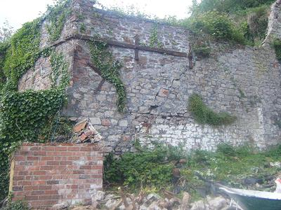
The large crack and retaining bar of the north side of the site shows the problems of instability very clearly.
- The impact statement merely says that some minor excavation for foundations will required and the finished scheme will increase the visual massing.
- How will all the heavy construction vehicles gain access to the site? The lane is very narrow at this point. It is also a sheer drop of about 4m to the site
- Where will the construction workers park?
- A huge amount of disruption to the visitor parking of the Avon Gorge Hotel will result for some considerable time.

Design:
- Bulk and mass. A 5 double bedroomed house on 4 levels. This confirms that the finished scheme will increase the visual massing of the terraces since there will be a build out on the upper section. Worryingly, the pre-plan proposal put to the Planning Department in 2009 was for six dwellings. It is now a single 5 double-bedroomed house. This suggests that the house may be let as five flats in the future, especially as the link between the four levels on two terraces is rather difficult.
- A sliding rubblestone vehicle gate and sliding rubblestone pedestrian gate would be very heavy. This is a grade II listed wall. The natural stone wall will be restored- yet most of the wall now appears to be gates. The application incorrectly states that vehicle access is not new. It also incorrectly states that pedestrian access is not new yet provides a new pedestrian gate, since the existing door appears to be for the use of 410 and 412 Hotwell Road.
- Right of way for 412 Hotwell Road would move to right hand side. The application incorrectly states that there is no diversion.
- No details about drainage are given except that it will be disposed of by soakaway. This will affect 412 Hotwell Road since more water will be channeled.
- There is no geological survey and structure report despite reference to one. The planning supporting statement merely states that the report demonstrates the ground conditions are suitable for the imposed light-weight load of the proposed dwelling. This building can hardly be described as light weight. A survey performed in 2010 showed concerns about the stability of the ground, as did a full geological survey in 1974.
- Princes Lane is private. Has the owner of the site permission to drive down there? Two cars parked on top of the roof, will be very visible.
- Owing to the recessed style of the windows to avoid glazing being seen from the bridge, the house will be very dark since it is confirmed that the glass is in shadow for most of the day. It is not possible to put windows to the north, so the only other glazing will be to the south. Therefore it is highly likely the windows will become bigger during construction. The skylights will also be prominent.
- It is claimed that the visual impact will be reduced by flora on green roofs and new walls.

Planning context
All policies are quoted but ignored and not followed. The planning supporting statement incorrectly states that a habitat survey, daytime bat assessment and geotechnical land desk study (a fundamental requirement due to the nature of the site) are included.
- Land Use
Confirms in the planning supporting statement that the site is not allocated for development.
!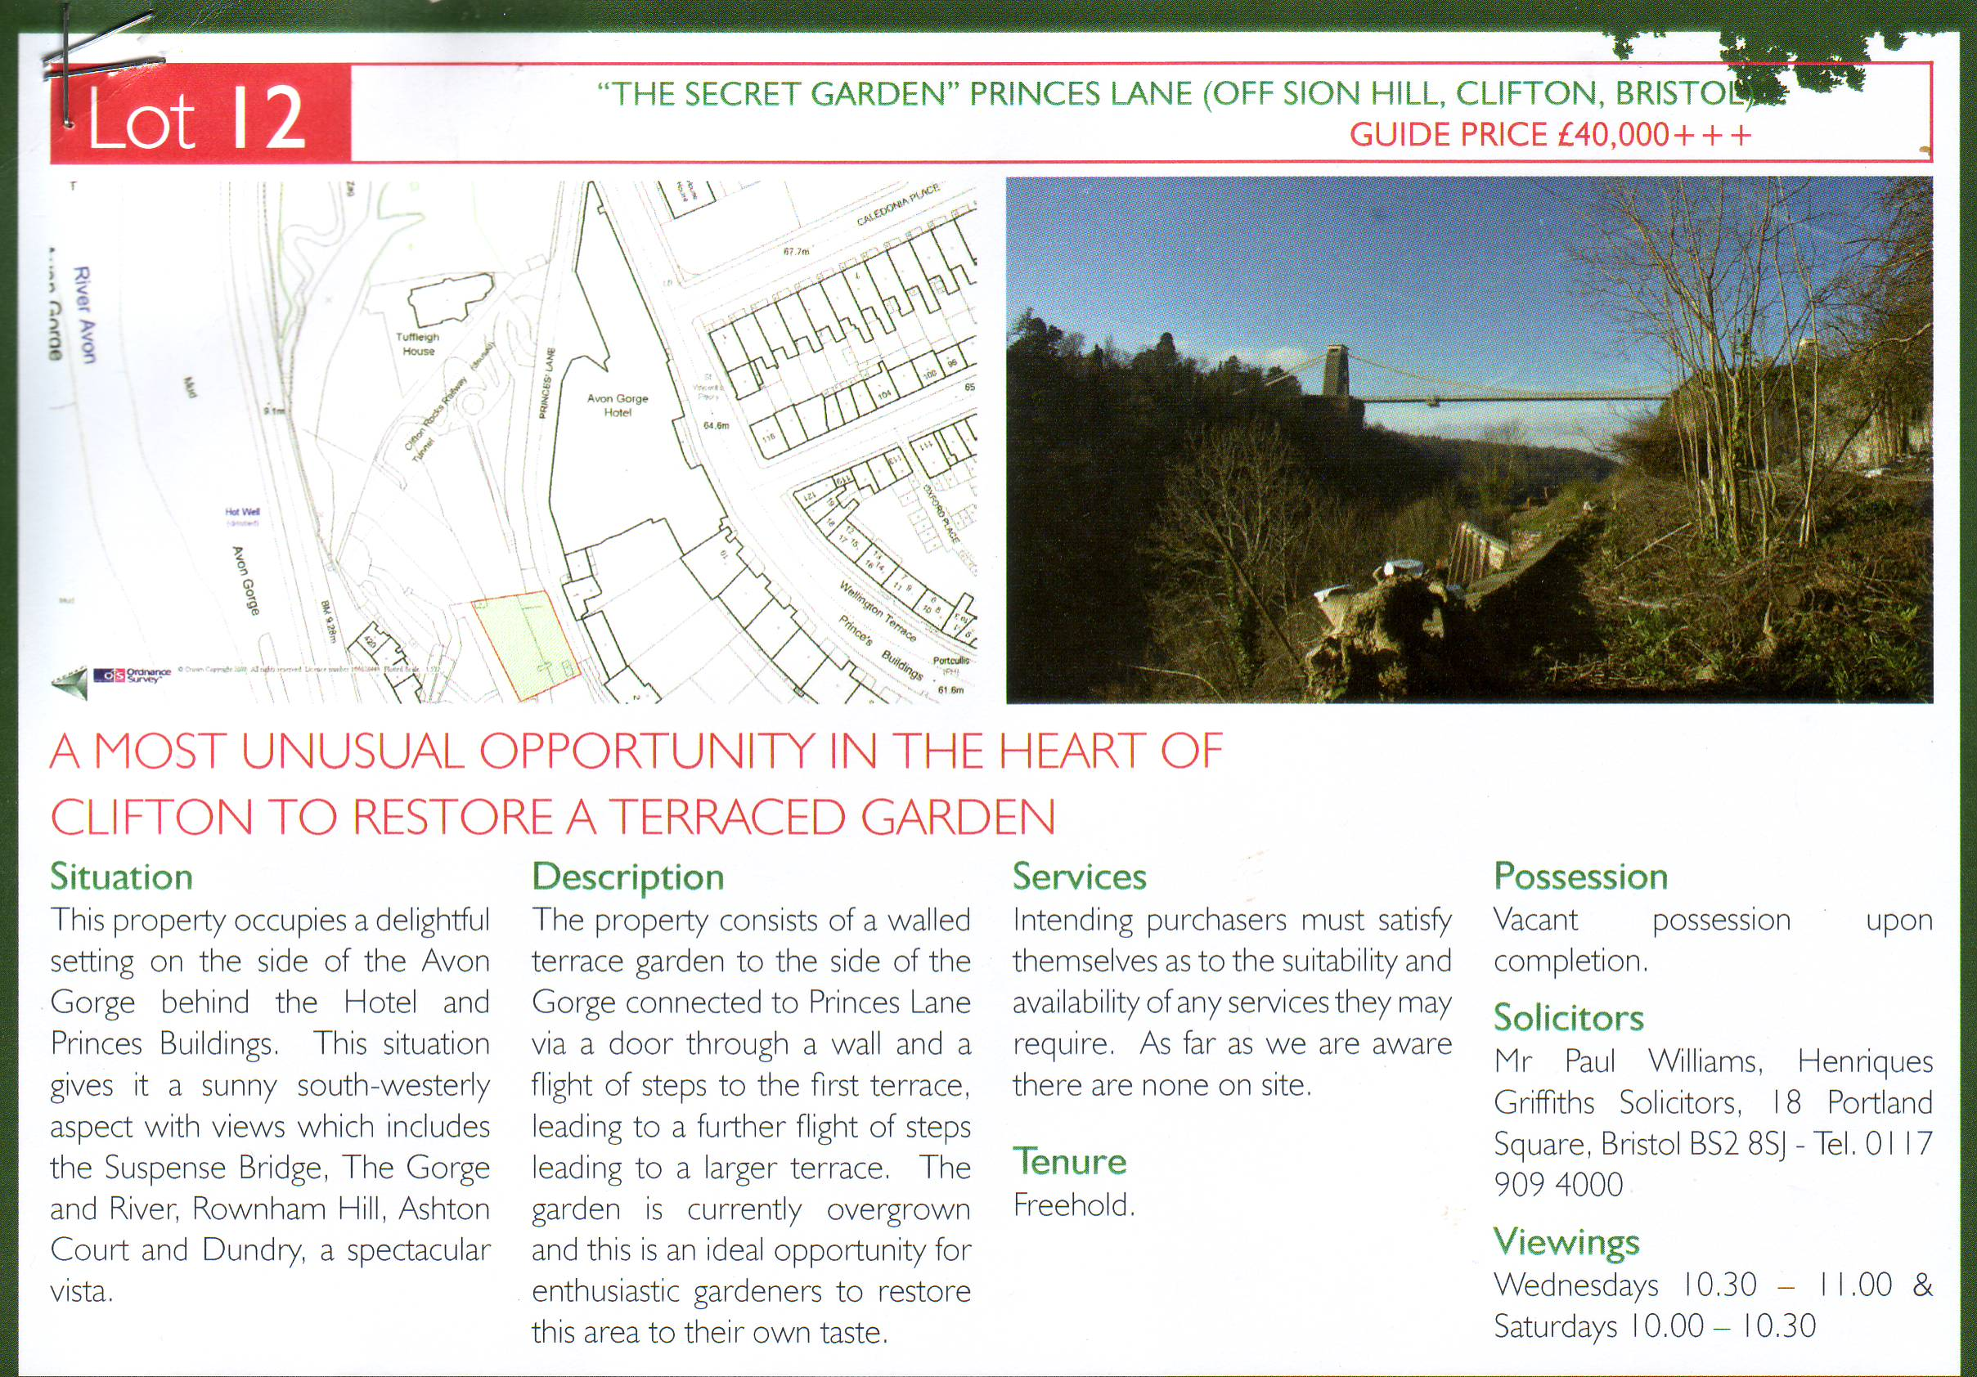
The auction details did not market it as a site for development - merely as a garden.
The planning supporting statement states there are no adopted policies which prohibit the principle of development on the site- yet then quotes all the policies which categorically show exactly why it should not be, and ignores the conclusion of the archaeological desk top study. It may be a windfall site to the purchaser if he/she is enabled to make a huge profit by developing it but it will be a sad loss to the area.
    - The applicant states that there are no international or national designations relating to application site or immediate surroundings, ignoring the Suspension Bridge. It is Special Area of Conservation and a Site Of Special Scientific Interest. The Clifton Appraisal describes the view as of international renown. The impact statement also defines views of very high level of sensitivity as being international, confirming that the views from the Bridge have an international designation.
    - LDF NE should be followed because of the historic landscape interest since:
(ii) Sites which are important for nature conservation, recreation, historic landscape interest, landscape quality, visual amenity, community or outdoor leisure-related use, or providing setting or relief to the built environment, defined on the Proposals Map, will be protected as open space.
iii) Development involving an unacceptable loss of important open space (designated in section II and defined on the Proposals Map), or which would have a significant adverse effect on the interest, use, amenity, character or accessibility of such open space, will not be permitted.
The impact statement claims that the private land is unused, so any impact on open space in terms of accessibility, character and openness is negligible. This is a Site Of Special Scientific Interest, an outstanding historic landscape full of character, The development will have a significant adverse effect with its huge walls and token green roof.( ii) has been conveniently forgotten as the importance of this historic site cannot be denied.
- NE2 is not followed since:
Prominent or strategically important landscape features which make a significant contribution to the landscape character of the city, including green hillsides, promontories, ridges, valleys, gorges and man-made landscapes will be protected. Development which would have a significant adverse effect on identified features of importance as defined on the Proposals Map will not be permitted.
The impact statement weakly says that the slope has been intensively modified by man and now lacks any naturalistic features. The developer has an obligation to repair the grade II walls.
- NE6 is not followed since:
The site has already been cleared so did not protect the city's wildlife network.
- NE9 is not followed since:
Historic parks and gardens and other designed landscapes of national and local importance defined on the Proposals Map and described in the Appendix will be protected. Development which would adversely affect the character or appearance of historic landscapes and, in the case of nationally important sites, their settings, will not be permitted.
The impact statement says that since the site cannot be seen from Clifton Down it will not have any visual impact. This is a designated landscape of international importance so NE9 is relevant.
- B1 is not followed since it does not take account of the local context, layout and form.
- B2 (not quoted in statement) is not followed: ‘development should be designed with regard to local context. Proposals which would impact negatively on the character or appearance of the Conservation Area, or to the visual impact of historic buildings, views or landmarks will not be permitted.’
- B5 is not followed since the proposal does not respond to the local context by having an appropriate layout and form. The applicant does not describe how he has addressed stability problems.
- B13 is not followed since:
Development should preserve Listed Buildings, their features and settings, and preserve or enhance the character or appearance of the city’s designated Conservation Areas, as defined on the Proposals Map. Development which conflicts with these objectives will not be permitted.
The impact statement refers to application 08/02756/F to build a parking area as a precedence, omitting to say that it is for a motorcycle on a raised platform and incorrectly stating that it will significantly modify the existing pedestrian entrance. The statement adds that raised terrace for the motorcycle should allow a new raised terrace for the house. It also states the walls used to be obscured by hot houses so can be obscured by huge house walls. It also states that the walls and steps do not contribute significantly to the settings of the listed buildings below. The orchard and gardens, remains of garden buildings and equipment, and spring bore holes are all part of the setting of this listed house. The application incorrectly states that the only works are to the side of existing steps, not admitting that it will be necessary to demolish and destroy all remains of listed garden buildings. The planning supporting statement quotes only the secondary part of the policy; new development can be integrated which responds to the character to give new interest and variety and avoiding mention of loss of setting. The Clifton and Hotwells Character Appraisal is given minimal and incorrect reference. A montage for the nearest viewpoint has been omitted on the basis that people do not look up.
- B15 states that townscape and landscape features that contribute to the character should be preserved and that development will not be permitted where it would unacceptably harm landscapes, open spaces and gardens .
The site has been cleared of fruit trees and needs listed walls to be repaired. The fruit trees should be replaced by fresh ones, not by a huge building. Parking a car on the roof leads to all sorts of problems: the wall is listed, the road is too narrow, there is no right of way, and the cars would be highly visible on the side of the Gorge. It also has an adverse visual impact from outstanding viewpoints such as the Suspension Bridge and the public right of way along the towpath.
- B16 relates to neighbouring historical buildings. This new building certainly does not reproduce the appearance of the architectural elements of the Colonnade and 412 Hotwell Road. Those houses are over 250 years old and a contemporary building is entirely inappropriate here. The last development in this area was over 120 years ago. The retaining walls of the terraces are solid in order to retain the earth behind them, their largeness also reflects the fact that they are on unstable ground which is unlikely to sustain a house any way. There are no windows in the retaining walls so it is rather strange to use as a precedent the windows under Windsor Terrace (which are not seen from the Suspension Bridge anyway).
- B19 relates to preserving listed buildings and settings from inappropriate alterations: applications for planning permission involving material alterations to a listed building or its curtilage that fail to preserve its features or setting will not be permitted.
- B20 states that demolition of listed structures will not be permitted without clear and convincing evidence that it can sustain an existing use and that the character of the main building will be enhanced or unaffected. The proposal certainly does not enhance 412 Hotwell Rd and could affect it badly during construction and afterwards. Redevelopment will provide no benefit to the community since a garden and a historic landscape will be lost.
- B21 relates to demolition in a conservation area. The orchard and garden made a positive contribution to the area, subservient to its surroundings within the context of this part of Clifton. The replacement building fails to do this and would result in a form of development that would be inappropriate in form, overall design and appearance.
- B22 relates to assessing the archaeological resource which confirms the development should not go ahead because the existing structures should be conserved and maintained.
- Clifton and Hotwells Appraisal (page 18) shows a view of the Gorge and states that the landscaped areas contribute to a characteristic image of Bristol. The preservation of views within and out of the conservation area is vital in protecting its character and special interest. It also states that loss of green space to new development is a main issue and loss of traditional garden plots to infill is not acceptable. The planning statement provides quotations from a non-existent paragraph and to non-existent wording. The planning supporting statement refers to paragraph 7.4.44-49 which is supposed to state that Hotwells comprises of domestic buildings in a variety of terraces, semi-detached villas and detached townhouses. Pennant is identified as the predominant boundary wall material. This is the limit of the reference- deeply worrying to give minimal, incorrect information from the appraisal of this specific Conservation Area!
- PPS3 seeks to improve affordability across the housing market but the resultant 5 double-bedroomed house will be anything but affordable.
- PPS5- the guidance is to preserve rather than to redevelop.
HE9.2 There should be a presumption in favour of the conservation of designated heritage assets and the more significant the designated heritage asset, the greater the presumption in favour of its conservation should be. Once lost, heritage assets cannot be replaced and their loss has a cultural, environmental, economic and social impact. Significance can be harmed or lost through alteration or destruction of the heritage asset or development within its setting. The criteria show that the historic connection between the elements will be lost, being no longer a vegetable garden/garden for visitors and orchard belonging to a grade II listed house, but a four storey house on a site where no development has occurred for over 250 years. The significance of the assets and impact on the historical landscape has been played down. There is evidence here of the natural springs for which the area was famous. This is a listed curtilage within the setting of an internationally renowned historic landscape.
HE9 provides a strong case to refuse demolition of the small structures:
  - HE9.2 iia) considers whether the nature of the heritage asset prevents all reasonable uses of the site. It should be an orchard again or a garden. Thus HE9.2 iia) is not followed
  - HE9.2 iid) checks whether the harm to or loss of the heritage asset is outweighed by the benefits of bringing the site back into use. It has always been a garden (for vegetables or for visitors) and orchard. There are small structures that could be restored as features. The harm to landscape and to the main grade II buildings by conversion to a four storey house must be considered. There is a real risk of damaging the grotto underneath – either during construction or by building on unstable land. Thus HE9.2 iid) is not followed.
HE10 When considering applications for development that affect the setting of a heritage asset, local planning authorities should treat favourably applications that preserve those elements of the setting that make a positive contribution to or better reveal the significance of the asset. When considering applications that do not do this, local planning authorities should weigh any such harm against the wider benefits of the application. The greater the negative impact on the significance of the heritage asset, the greater the benefits that will be needed to justify approval.
The statement quotes this guidance but avoids HE9 by making no further reference to it. It claims to comply with HE7 (which is a Local Authority guidance) and HE10 (which is significantly not quoted in full - the boldened part is omitted). It only states that HE10 is the most relevant. The visual impact statement is highly relevant to HE10, which is highly subjective. This development will not better reveal the significance of the asset because it will destroy the historical listed garden and its structures and its connection to 412 Hotwell Rd. Stating only that it complies with HE7 and HE10 confirms that it does not comply with HE9. It confirms the grotto is of note; ignores the setting of the II* Colonnade and states that the retaining walls are utilitarian in appearance and largely unremarkable and have limited merit (but not regarded as so special they cannot be altered but do form part of the general landscape). Significantly it states that they may well have been built to stabilize the ground and enabled the terraces to be used in an ancillary way (as gardens for visitors, vegetable gardens and orchards for the Hotel and 412 Hotwell Rd, but certainly not for building houses on). The archaeological desk-top study also concludes that the developer should seek to maintain the existing structures thus conserving the archaeology so it does not comply with HE10
- PPG16 (referred to in the desk top study) states that there should be a presumption in favour of physical preservation of archaeological remains and concludes that the remains of the structures should be maintained. Thus PPG16 is not complied with.

Consultation:
Both the Clifton and Hotwells Improvement Society, and the Conservation Advisory Panel strongly objected to development taking place when consulted in 2009. Their comments are not repeated in the developer's statements. This is the only community involvement that has taken place - surprising for such a significant application. The statement, with no evidence, states that the house has been designed in response to responses from third parties as well as the planning authority.
- CAP: However, the pre-application could be considered as a matter of principle. Nothing had been built between Tuffleigh House and Windsor Terrace for at least 100 years. This was an important part of the landscape of a nationally important conservation area and iconic view of Bristol from the Suspension bridge. The public inquiry in 1971 on the hotel extension established the importance of this hillside. Setting aside the practicality of access, construction and services on this site, the terraces and walls would be obscured by the proposed development.
The historic fabric and form must be preserved and retained. The previous buildings on the site were merely glass houses and sheds.
A dwelling inevitably would have domestic paraphenalia, thus damaging the view. The slope is also a wildlife haven which must not be disturbed.
The panel strongly objected. However, they were clear that the land had been sold as a garden, and that there should be no development of the face of the Gorge.
- CHIS: have consistently opposed the development of all private open space in Clifton over the past five years on the grounds that Clifton is already over-developed, and that in a conservation area the space between buildings is as important as the buildings themselves. CHIS was created 40 years ago to oppose development on the face of the Gorge and wishes to remain true to its principles.
They were also of the opinion that the access on Prince’s Lane was far too narrow, and that any attempt at building would threaten the properties on the Portway below. The problems of rubbish disposal, let alone services and drains, or the provision of car parking space had clearly not been addressed. They were clear that they would oppose any proposal, however ingenious.

Heritage Statement
- 4.1 states that the garden structures remained on the site until the 1950s. They are still there. Both the heritage statement and the archaeological desk-top study show photographs of them. There is also a historic bore hole in situ (not noticed by the City Archaeologist). It acknowledges the grotto on the level below the site.
- 4.2 states that the site is not visible from Princes Lane or Hotwells Road. This is not true. Down the lane one only has to look over the wall to see it, as from the hotel terrace, and from Hotwell Rd as the developer has defined it as viewpoint 15 and can be seen in my photograph below. ‘Unused for years, it neverthless had some fine apple trees until the developer cleared them.
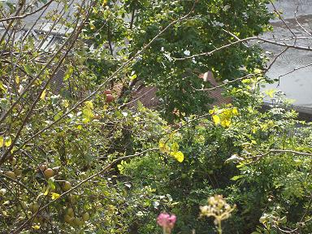  Apple tree removed by developer. | 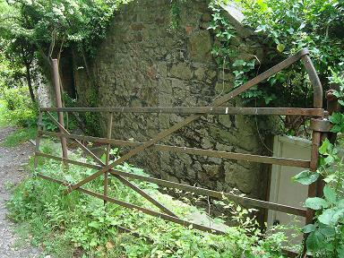  Current entrance down steps and through a small doorway.
- 4.5 again states incorrectly that the site cannot be seen from the eastern side of the Avon. It can from Princes Lane and Hotwells Rd.
- 4.6 refers to constraints of pedestrian and vehicular access off Princes Lane, which is a private lane. It may not be possible to gain vehicular access to the site. It also twice lists site access for construction as a constraint - probably because of the difficulty in getting site access for construction vehicles and equipment given the height of the lane above the site, the narrowness of the lane, and the layout of the site itself.
The plan refers to approved planning consent for a parking area as a justification for parking two cars- failing to point out that it is for a motor cycle. Proposed plan 4 even draws a picture of a car. The current access to the site (shown above) is not altered by the approved plan - unlike the proposed one.
- refers to no glass being seen from the south side of the Suspension Bridge and occupants of the house not having direct views of the Bridge. The windows will be recessed by at least 1100mm but are 1100mm wide, down the whole side of the building and clearly seen from the towpath. Windows are not possible on the north or the east sides owing to the constraints of the site.
- states that refuse collection will be made from the top of the lane. A house with five double bedrooms that can house ten people, could generate rather a lot of rubbish. It is not practical to be 125 metres away up a hill. The applicant was advised by Charlotte Sangway that the Highways Department would find the application unacceptable if bins had to be pushed more than 30 metres. There are no details about other services in this section. Clearly there is currently no mains or water supply to the site, nor a sewerage system.

Landscape and visual impact
All policies relating to landscape are quoted but not fulfilled since all state why development should not take place. The statement confirms that the site
- lies within area of high landscape/townscape and visual sensitivity.
- lies within landscape of significant historical and aesthetic value.
- the remodelling of the hill achieved by the construction of massive retaining walls strongly defines the character of this part of the Gorge.
- retaining walls of site are curtilage listed. The proposal will impinge on grade II listed Rock House (412 Hotwell Rd) in particular since there has never been a development here. Paragraph 7.20 of the Landscape statement suggests it does not impinge on the settings of 412 Hotwell Rd and the Colonnade because it is sufficiently elevated - elevation is simply irrelevant. The significance of the garden will be lost by building a four-storey house, and green space will be lost. The garden used to belong to 412 Hotwell Road until the previous owner sold it. The landscape in this part has been little changed for well over 100 years. The historic connection between the elements will be lost as it will no longer be a walled vegetable garden but a new four-storey house. The site cannot be considered in isolation to these buildings. Thus the application contravenes PPS5 (and B1, B2, B13, B14, B19 and B20) and will cause substantial harm to the character of the landscape.
- the entire landscape surrounding the site is very sensitive to change since it is a visible and integral part of the unique landscape of the Avon Gorge. The combination of the natural landscape of the Gorge, the Grade I listed Suspension Bridge and the Georgian architecture of Clifton results in a landscape of national importance and international renown (confirmed in 6.59). 3.2 of the landscape statement, however, states that there are no international or national landscape designations.
- It is part of a Site of Special Scientific Interest.
- It seems to have forgotten that it is in a Special Area of Conservation.
- Visual assessment protocol normally requires views from a private property to be considered, but then states it was impractical (5.8) – why was not Rock House considered since this is the most affected property?
- There are views of the site from the edge of the Avon Gorge Hotel terrace- a very popular venue, as from the lower floors when restored. It must also be visible from 2 Princes Lane.
- It reduces visibility of the Avon Gorge buildings down the lane.
- Public rights of way are a landscape and visual consideration. The site is visible from the well-used towpath across the river.
- The ground could cause the building to slide. Pile driving is not beneficial to the topography and construction could cause real problems for the grade II* and II houses below. It is confirmed that the residual effect of construction is adverse. Vibration could well damage and compromise existing structures.
- It will increase the visual massing of the terraces since there will be a build-out on the upper section. This is not beneficial to a landscape of national importance and international renown despite the claims in 7.12
- It will be the only 21st century building in this part of the Conservation Area. A contrast to Rock House (1741) and the Colonnade (1786). The impact can hardly be described as neutral (7.22). It would be far more beneficial to repair the listed walls. Neglect is no reason for development in such a sensitive area. Land use in Hotwells is not indeterminate- it has some of the most historic buildings in the area and this landscape is a historic part. A purpose does not have to be established. If this building is allowed, it may start a precedent whereby all the owners of Princes Buildings are encouraged to build at the bottom of their gardens, and the Hotel build on its terraces. There would be an inescapably significant adverse impact on the Hotwells Landscape Character Area.
Viewpoint 1- First view from Suspension Bridge: Confirms that the site can be seen for three quarters of the Bridge and that the sensitivity of the site is very high. All views from the Bridge will have a major adverse visual impact on a very high sensitive view because of its bulk and massing and two cars stuck on its roof. The loss of greenery will be missed. The cleared site is an eyesore. The visual impact cannot be described as neutral.
Viewpoint 2- Centre view from Suspension Bridge: Confirms that the site is in the middle distance of a spectacular panorama.
Viewpoint 3- three quarters of the way: terracing and grotto of 412 Hotwell Road now clearly seen. The development shows as an anomaly where one would expect to see an orchard and gardens.
Viewpoint 4- west side of Bridge. Described as the most significant viewpoint because one is drawn to view the site. If the walls are dilapidated they should be repaired, not replaced by a large five double-bedroomed house on two levels of the terrace. The magnitude of change is described as high so this point has the most adverse visual impact.
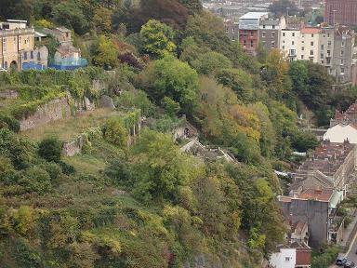  Before site cleared Far more natural view. The original greenery will be covered by a solid mass which cannot be camouflaged by ivy. | 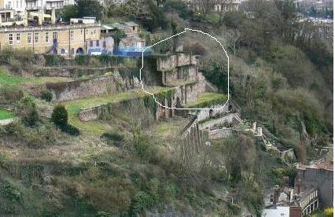  view 4: Now a solid mass of stone wall. Far more prominent than the landscaped walls, dwarfing the grotto.
Viewpoint 8-10 towpath on west bank of the Avon. The range of view from the towpath covers about 480m between Freeland Place and the Zig Zag path and the site is very prominent, confirmed as high sensitivity. The opportunities to see the site are not as constrained by trees as much as the statement says, even in the middle of summer. The grotto can clearly be seen and pulls the eye to the site. It is amazing that the statement claims that the terraces have limited visual appeal. The buildings below the Hotel terrace (stables and cottages) are far more fitting. The impact is certainly not neutral but negative in such a historic landscape. The site dominates the scene. The design is certainly not sensitive to its setting.
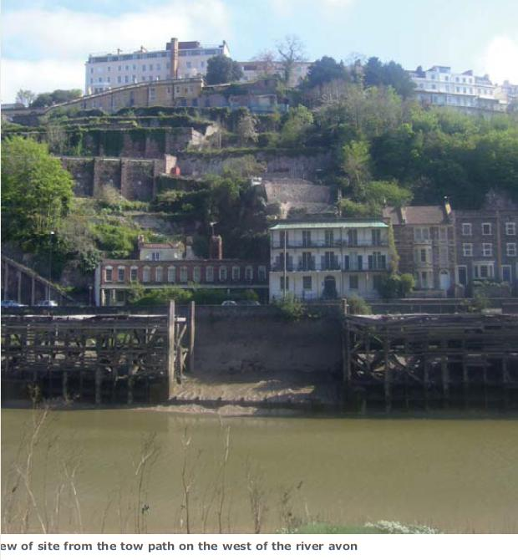  A separating frame of greenery between the walls and buildings above and a welcome step down from retaining walls of the north to the trees of the south. | 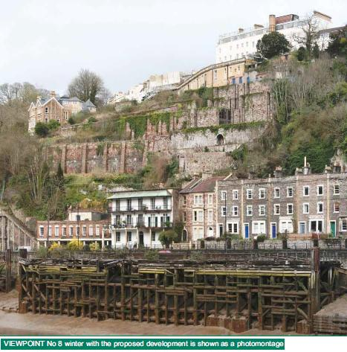  A tall solid mass of clearly contemporary design with large windows, which clashes with the historic grotto wall, houses with small windows and the retaining walls lacks subtlety which no camouflage could hide or improve.
Viewpoint 15: Hotwell Rd. The site is clearly visible to people using the footway, but the majority of users they are unlikely to look up. A montage has not even been given - and yet this is the nearest point of viewing and would give the clearest idea of what is to be built. It blocks the view of the buildings of the Hotel - all part of the history of the area and which are likely to be restored in the near future. It will ruin the setting of the II* Colonnade and grade II 412 Hotwell Rd. Many people walk by and admire the Colonnade and then their eyes are automatically drawn upwards at the rest of the landscape. How can it be claimed to be of no significant impact and that the sensitivity of the view is low?
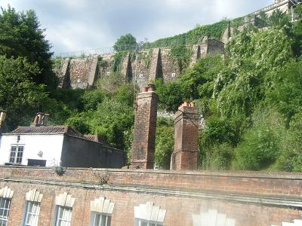  ‘No view from the Colonnade’ As if … | 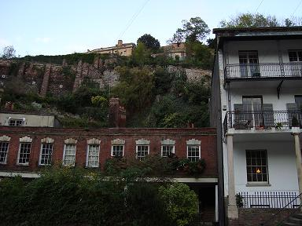

Conclusion and Summary
Despite the claim that it will only be visible from a very small number of public and private viewpoints, those are highly significant viewpoints being from three quarters of the grade I Suspension Bridge, 480 metres of the tow path of a special area of conservation; and 100 metres of the Hotwell Road above grade II* buildings. At a spot where one expects to see orchards and gardens of 412 Hotwell Road, the echoed form of the massive retaining walls will be very prominent.
The planning supporting statement is embarrassing in its reasoning.
- It constructs an extreme distortion by stating that it sits in a location that has been intensively modified by man and lacks any naturalistic features, so the relevant importance of the site as a feature is deemed to be negligible.
- To say it is only visible from very specific and a few distant locations is ridiculous when one can observe it from three quarters of the Suspension Bridge, 480 metres of a public towpath, from Princes Lane, from the Hotel terrace, from Hotwell Road (but we are told that people would not look up to see it). This is in a Special Area of Conservation and part of an internationally acclaimed landscape.
- The development precedents were built over 100 years ago. Avonwood does not have relevance; it is in a residential area, not in view of the Suspension Bridge, and not within the curtilage of a grade II listed building.
- Conversion of Tuffleigh House (built 1896) into flats is not relevant. It was large, in place and derelict but now provides more sustainable housing.
- The archaeological desk-top study concluded that the terracing constitutes historical/ landscape archaeology and considers that any development of the site should seek to maintain the existing structures thus conserving the archaeology which is at this present time in a bad state of deterioration. Somehow this is interpreted to mean that there is limited potential on the site
- Residents would be expected to move their refuse 125 metres up hill (far greater than the maximum specified limit of 30m specified by the Highways Department), yet the statement says that receptacles can easily be temporarily stored at the junction.
- The statement that there are no adopted policies which prohibit the principle of development on the site is contradicted when all the policies which refute this are quoted.
- Described as a windfall site, more correctly it is a land locked garden. It may be a windfall only if a huge profit results from development it but that would be at the expense of the area. It would be a sad loss.
- There are alleged sustainable urban drainage measures incorporating rainwater harvesting but no details of drainage, no mains sewerage, no electricity, no water supply. Where are the mains sewer and the water supply to be used? Where will the electricity supply come from?
- All historic fabric will be preserved – at the cost of covering it all over.
It should also be noted (figure 7.2) that all the changes due to the development are irreversible and permanent (by a high level of certainty) on this highly sensitive historic landscape. The alleged negligible residual impacts are highly debatable. It is incorrect to state that the character and appearance of the walled hillside will remain little altered by a huge house with five double bedrooms on four levels with a car park on top of its roof, which involves removing part of the listed wall of Princes Lane to gain access. This is to replace a small door in a wall down some steps leading to a secret garden.
The merit of the replacement scheme is poor. It does not reflect an appropriate form of development that has regard to the character and appearance of the Conservation Area. It is an over-intensive form of development. Light to the building is poor since the windows to the west have to be recessed, and it is not possible to put windows to north or east. No cycle rack appears to be provided though the application states there are two. There are severe doubts as to whether the site is strong enough to support the building and no structural survey has been provided to prove this. There is a severe risk to the listed houses in Hotwell Road both during construction and afterwards.
Only one site notice was posted, quite inadequately and right at the bottom of the lane. Surely a notice in a more prominent spot such as the post at the junction of Sion Lane and Princes Lane would have been far more suitable, more people would have been made aware of such a sensitive application. A notification list has not been included of the number of people who have been contacted.
This application to demolish the listed structures and destroy a garden, paths and orchard should be rejected. Insufficient justification has been made to allow for the demolition. Furthermore the proposed replacement building does not represent an exceptional replacement that would carry sufficient weight to justify such demolition. Therefore the demolition is contrary to the advice contained in PPS5 in particular HE9. English Heritage would likely agree. The application also contravenes B1, B2, B5, B13, B15, B16, B19, B20, B21 and B22 and will cause substantial harm to the character of the area and Rock House in particular. It is not appropriate to develop this site. The supporting statements are misleading in their references to policy statements and it is inexcusable to quote non-existent information from the Clifton and Hotwells Character Appraisal and thus give totally meaningless reference to it.
There is a historic bore hole in situ (not noticed by the City Archaeologist). This site holds the only evidence left of the historic spring industry of Hotwell Spa so is very significant. In view of this we consider that there should be a full archaeological survey regardless of whether the application is passed or not. The land has already been cleared of trees and so is accessible.
It would be more beneficial for the land to be replanted with the orchard trees it had until recently. The auction catalogue details clearly stated that this was a garden, not a building plot, so why the developer considers that it should be developed is a mystery to all concerned. The development benefits only the developer and not the community and the Clifton Conservation Area or Bristol as a whole. It may also set a precedent for other applications to develop the terraces.
It is vital to have this application refused.

Maggie Shapland
On behalf of Clifton and Hotwells Improvement Society (CHIS), a society of over 1,000 members.

